**How to Figure out what Blood Collection Tube to Use:**

1. Click the STAR in top left corner of desktop

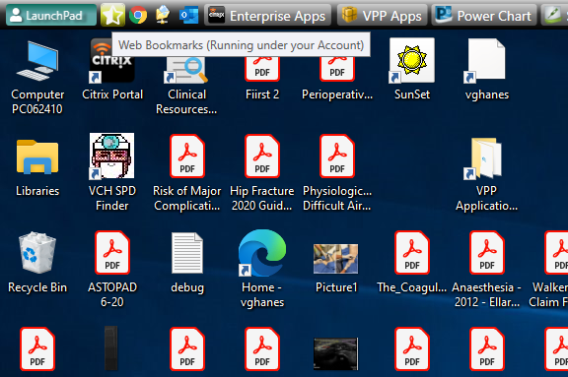

1. Click through to VCH Lab Test Manual

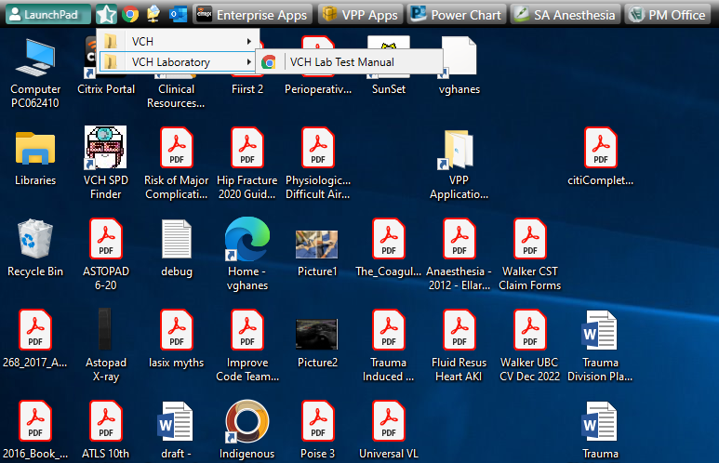

1. Once the Manual opens Click <Ctrl + F > to search for the lab test you are interested in. e.g. “Tryptase”

